Bas Boorsma
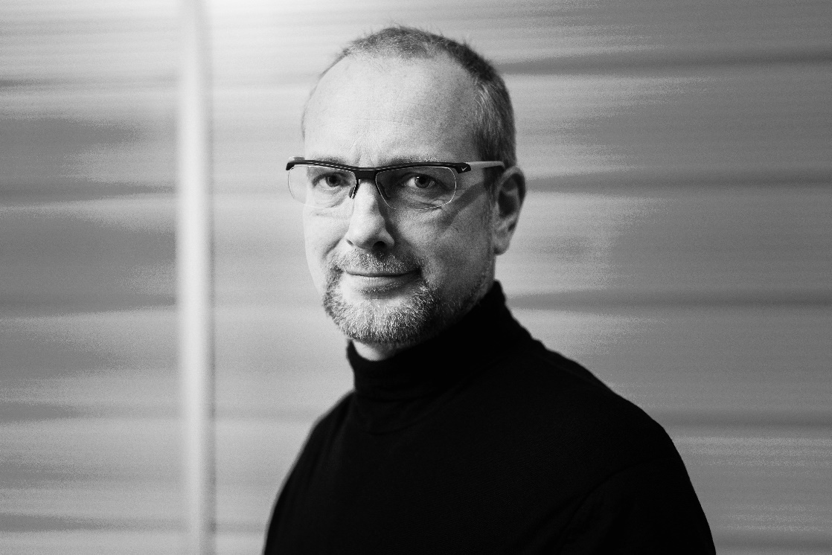
Chief Digital Officer, City of Rotterdam | Professor of Practice, Thunderbird School of Global Management at Arizona State University | Vice President at Cities Today Institute | | Former Digitization Leader at Cisco | Author of "A New Digital Deal" | Member of the Board, The Smart City Association Italy (TSCAI)
-
Bas is a leading urban innovation and digitalization specialist & executive with 20 years of experience in the 'smart city' space. As per August 1, 2021, Bas serves as the (external) CDO to the City of Rotterdam. In this capacity Bas is lead orchestrator, facilitator and ambassador to the city and its innovation ecosystem. Bas also serves as Professor of Practice at the Thunderbird School of Global Management at Arizona State University. Bas is also Vice President EMEA of the Cities Today Institute, and also serves as Chief Innovation Officer at Change= (change-is.com), a fast-growing Living as a Service company. He also serves as Member of the Board, at the Smart City Association Italy (TSCAI). Bas is the author of the well acclaimed book "A New Digital Deal". (September 2017/February 2020 (revised 2020 edition) - www.anewdigitaldeal.com).
Bas served in various global and regional leadership positions at Cisco (2007-2018). From 2015 to 2018, Bas served as Cisco's Digitization lead for the Northern European region at Cisco. In this capacity he managed a series of city engagements, leading the way on Internet of Things related innovations for, with and in cities.
Specialties: Community Innovation. Internet of Things. Smart Cities. Future of Work. Complex Governance Structures & initiating and managing them. Entrepreneurship. Carving our niches and new markets. Forging a vision and then 'run' with it: Linking leadership & innovations to opportunities and platform.
Bas is married, has three sons and resides in the Netherlands

